Mr. Hilal Ahmad Rather,
Orderly.

Subject: Explanation Sought for Non-Completion of Assigned Task and Unprofessional Conduct.
It has come to my attention that you failed to complete a task assigned to you, providing inadequate reasons for the failure. You are habitual of doing the same. Furthermore, you engaged in an unprofessional argument with the undersigned in the presence of other officers and staff, which disrupted the institution’s decorum and fostered an environment of indiscipline. Such behaviour is unacceptable and contrary to the standards of professionalism expected within our institution.
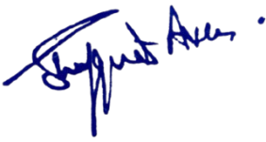
You are hereby required to submit a written response to this explanation addressing both your failure to complete the assigned task and your conduct during the incident. This explanation must be submitted within two days of receiving this letter. Failure to provide a satisfactory response within the stipulated timeframe may lead to further disciplinary action as per the rules.
No:No: KGP/Estt/2025/932-933
DaaDated:30-08-2025

Principal
Kashmir Government Polytechnic College
Srinagar

Copy to the:
1. Director, Skill Development Department for information.
2. Accounts Section with the instructions to withhold the salary of the official.
3. Office File

